**Weekly Updates for Project - L00188548**

**Week 1 Update – Project Overview and Planning**

In the beginning of the week, I went over the topic I was assigned for research, An Assessment of Environmental Monitoring Solution for Data Centre HVAC: Lightweight and Open Source. I made sure that I spent some time grappling with the relevance of data centre uptime and the HVAC systems uptime in regard to sensor-based temperature, humidity, and airflow fail-safe systems as well as preventative mechanisms.

For now, I have sketched a rough draft of a workflow of how to balance the theory component (finding information on tools and industry standards) and practice component (using open source Zabbix or Prometheus + Grafana). My goal is to implement a basic monitoring system on a physical or virtual machine in the next few weeks.

**Week 2 Update – Theoretical Background Research**

This week, I concentrated on the project’s theoretical side. I looked into the role of the environment factors, particularly temperature and humidity, in data centres. I discovered that improper control of the HVAC system can result in equipment overheating, degradation, and downtime, which is highly avoidable and expensive.  
  
I examined the typical monitored parameters: temperature (°C), relative humidity (%), airflow (CFM), and occasionally power consumption. I researched ASHRAE controls for data centre environments and noted their suggested values. These standards will be useful later when I analyse the effectiveness of each monitoring tool.

**Week 3 Update – Choosing Tools for Evaluation**

This week I worked on picking the tools, specifically the monitoring tools I'll be testing, and Zabbix and Prometheus + Grafana were the tools I'd chosen after some readings and YouTube walk throughs.

Zabbix has an alerting system as well as dashboards which lined up with my requirements thus making it a solid all-in-one platform. I liked the fact that Prometheus had Grafana as a separate entity to handle dashboards, View Dashboards., as it made it more modular. The decision to pick these two tools was mostly because of them being lightweight, well maintained, and having strong communities. Seeing as I was actively looking for those criteria, I made the right choice.

Next week I’ll begin setting up the tools on my test machine.

**Week 4 Update – Environment Setup and Installation**

I started the practical part this week. Using the official documentation, I set up Zabbix on a Linux VM. After some work, I finally managed to get a basic dashboard running, although I had to put in some effort to get the database and frontend working.

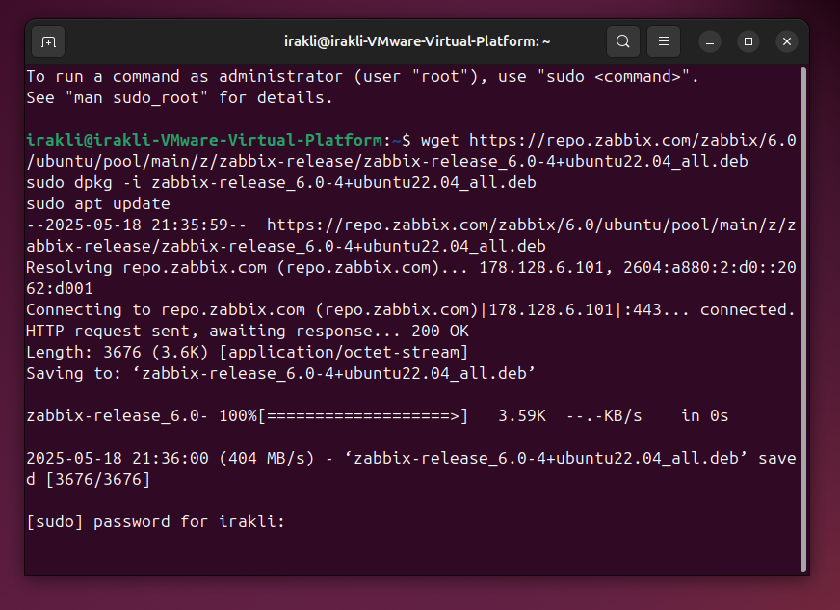

**Week 5 Update – Prometheus & Grafana Setup Completed**

Zabbix didn’t exactly work as I was expecting so instead, I will be going with Prometheus + Grafana.

I completed the configuration of Prometheus and Grafana for the practical section. The emphasis was placed on creating an open-source monitoring system that emulates data collection from a data centre in an HVAC manner. The installation is extremely low cost and remains graphical in nature, whilst serving as a strong starting point for evaluating the effectiveness of open source tools for monitoring HVAC systems in data centres.

I executed the manual installation of Prometheus on my Ubuntu 24.04 virtual machine and set it as a system service so that it runs in the background.

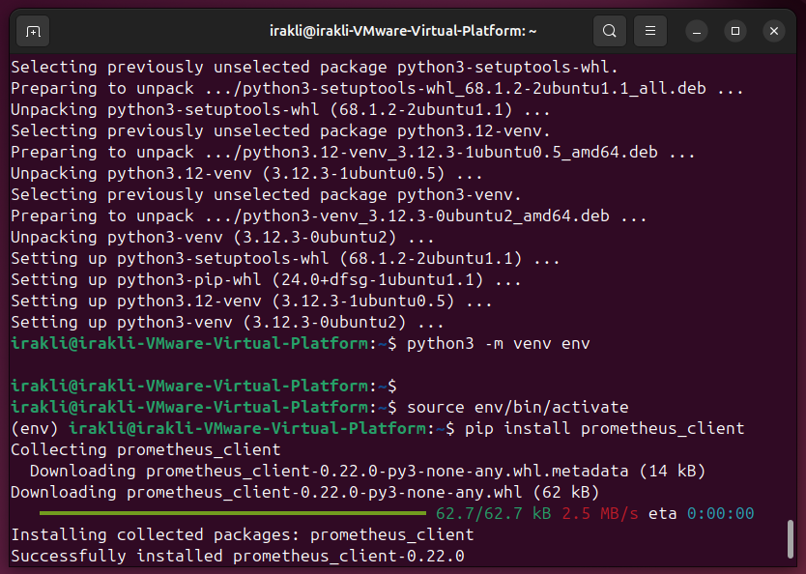

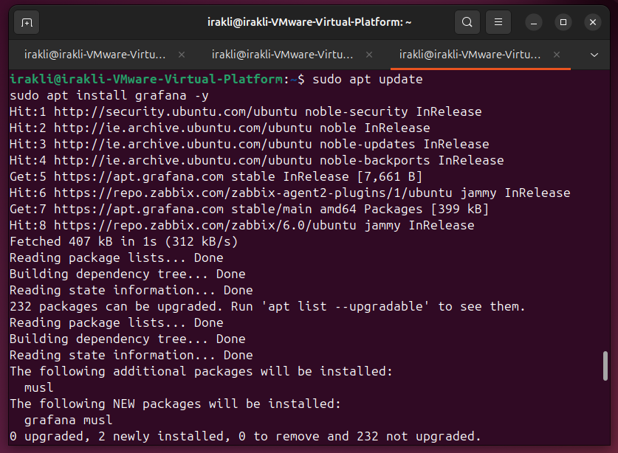

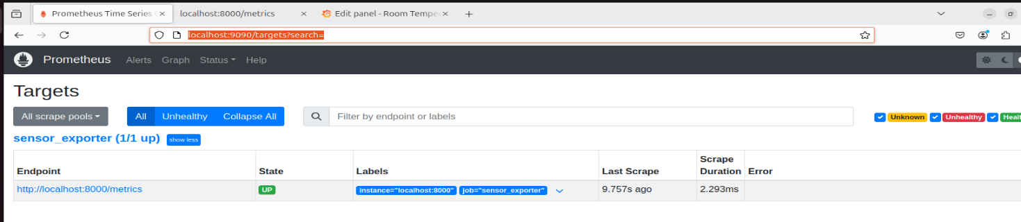

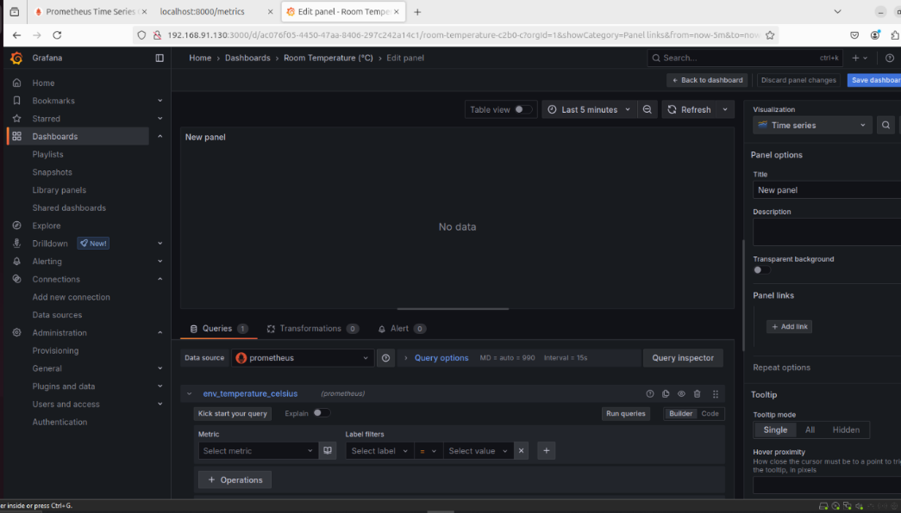

**Week 6 Update – Added Pyhton script**

I configured Prometheus to scrape data from a custom Python based exporter script that simulates temperature and humidity readings, The data updates every 5 seconds so it feels real time, even though it's not from physical sensors.



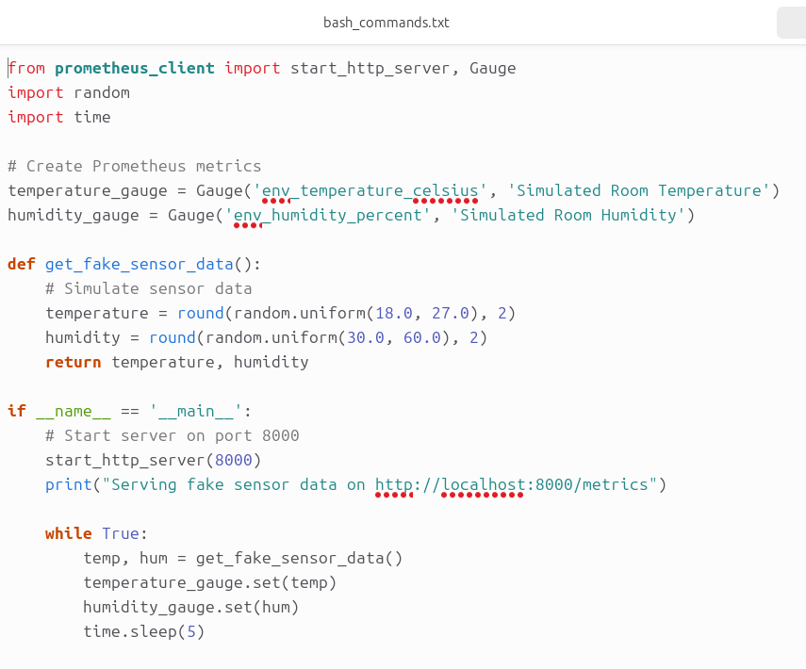

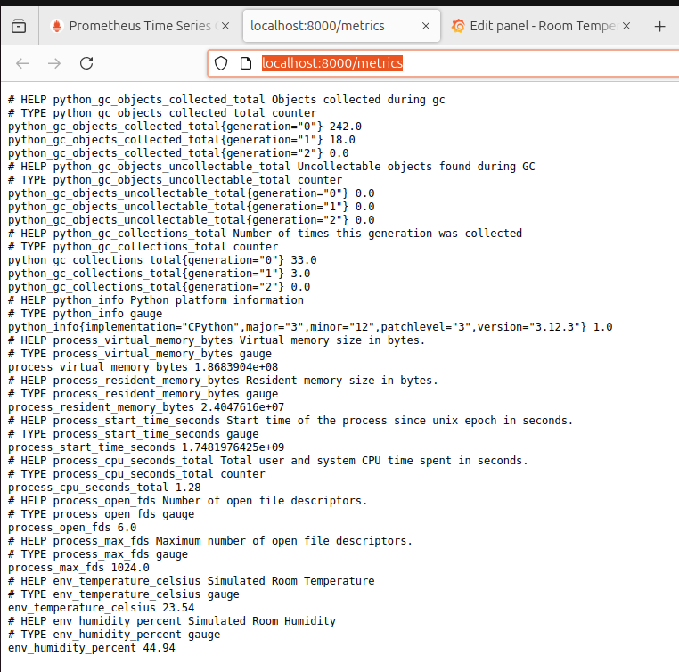

**Week 7 Update - Comparative Analysis**

| **Tool** | **Setup Difficulty** | **Resource Usage** | **Dashboard Quality** | **Flexibility** | **Alerting** |
| --- | --- | --- | --- | --- | --- |
| Prometheus + Grafana | Easy with Docker | Low | Excellent | High | Needs extra config |

In short, Prometheus + Grafana was modular and lighter, with better dashboards but needed more configuration for alerts. Both could work for HVAC monitoring, but for a lightweight setup, I’d lean toward Prometheus/Grafana.

